

Version 2024
Review date 2025

Epilepsy Care Plan

Child’s Name
NHS Number
Date of birth
Emergency contact details -Parent/carer
Emergency contact details- Parent/ carer | Care settings and other professionals to use this plan

Diagnosis –

What do …………… seizures look like?

What happens before and after?

How long do they usually last?

Any Triggers?

Usual recovery time and intervention?

Parent/Carer’s signature: | Print name:
Nurse’s signature: | Print name:
Date developed: | Review date:
Comfort and reassure. __________may be tired and need to sleep. If required – Provide basic first aid and make environment safe, put___________ in the recovery position and maintain airway.

Do they have emergency medication? YES NO If yes, please turn over

2/4
1/4
Has the child been prescribed a second dose? YES NO

Second dose for same seizure: ONLY if specified by the child’s consultant. ALWAYS call an ambulance.
mg
DOSE TO BE ADMINISTERED: ONE PRE-FILLED ORAL SYRINGE OF BUCCAL MIDAZOLAM
Administer after_______minutes from first dose if seizures show no signs of resolving
Child is ONLY able to have 2 doses of Buccal midazolam in 24 hours
Parents signature: | Print name:
Nurse’s signature (Designation): | Print name:
Date developed: | Annual review date:
STEP | HOW TO ADMINISTER BUCCAL MIDAZOLAM  Please note the time that the medication has been given to pass on to emergency services or parents
1 | Take one plastic tube, break the seal (if there is one) and pull the cap off. Take the syringe out of the tube
2 | Remove the syringe cap and dispose of it safely
3 | Gently insert the syringe in the space between the inside of the cheek and the lower gum (buccal cavity)
4 | Slowly press the syringe plunger to release the whole amount of the buccal midazolam into the side of the mouth
5 | Remove the syringe from the child’s mouth, keep the empty syringe to give to a doctor or paramedic so they know what dose has been given
Child’s Name
NHS Number
Date of birth

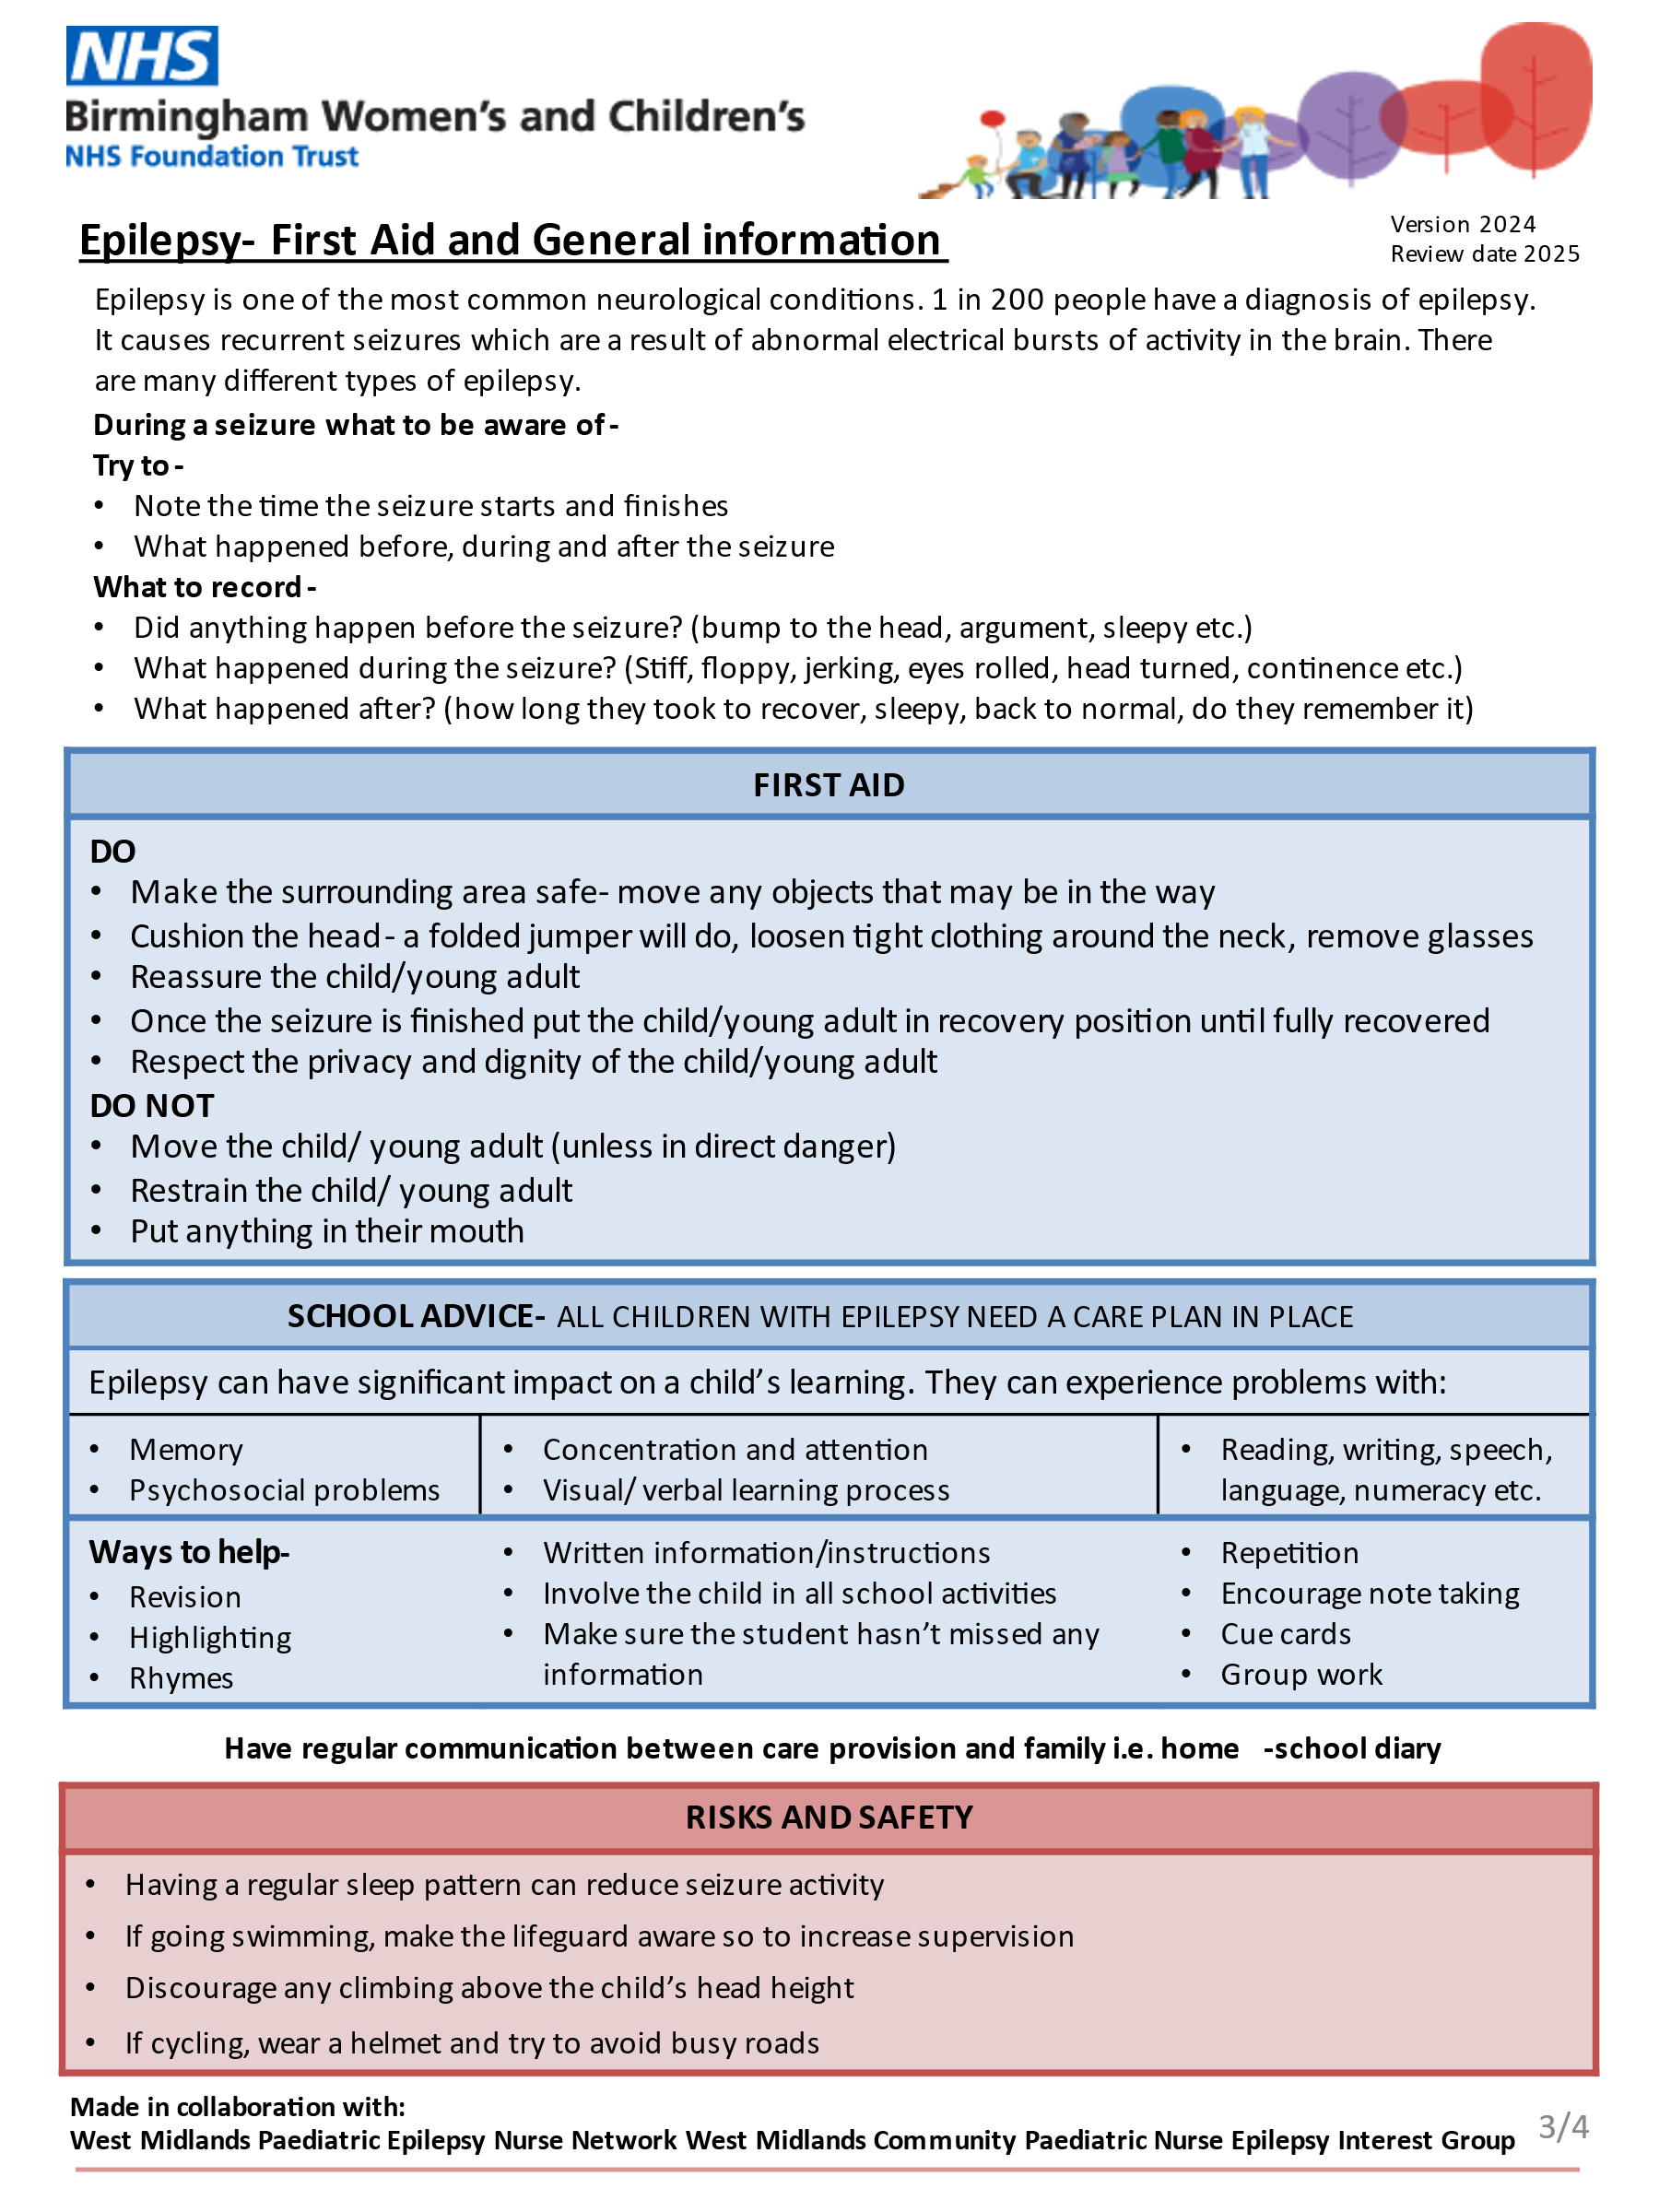
DOSE TO BE ADMINISTERED: ONE PRE-FILLED ORAL SYRINGE of BUCCAL MIDAZOLAM
ROUTE: BUCCAL (between a cheek and gum)
To be given if __________ has generalised Tonic Clonic seizure lasting longer than:________Minutes
Other circumstances to give a dose of Buccal Midazolam (e.g. other seizure types or cluster seizures)

If no effect after 5 minutes following administration of Buccal Midazolam- call 999
mg
2/4
DOSES IN 24HRS FOR ADDITIONAL SEIZURES
Child can have 2 Doses of Midazolam for a separate seizure in a 24hr period.
There must be a gap of 6 Hours between doses before an additional dose of Midazolam is given.
IF MORE THAN ONE DOSE IS USED IN 24HRS TO CALL 999 FOR REVIEW.
When to call for an ambulance:
- If it is the first time giving the rescue medication to this child in this setting
- If the seizure has not stopped after 5 minutes following administration of Buccal midazolam
- If concerned
Version 2024
Review date 2025
Emergency Medication Care Plan- if not applicable please cross off

