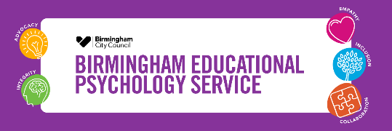


Framework 4 Intervention Revised
The Handbook

Introduction
Framework 4 Intervention Revised is a practical resource for school-based teams, which helps to guide decision-making for children and young people with social, emotional and mental health needs. It provides a framework to work through and exploratory tools to plan for universal provision, targeted action and specialist support. Designed first and foremost to improve outcomes for children and young people experiencing challenges with their social, emotional and mental health, the resource also helps school‑based teams to clearly record and evidence ordinarily available strategies, targeted interventions and progress within the graduated approach.
Underpinning Principles
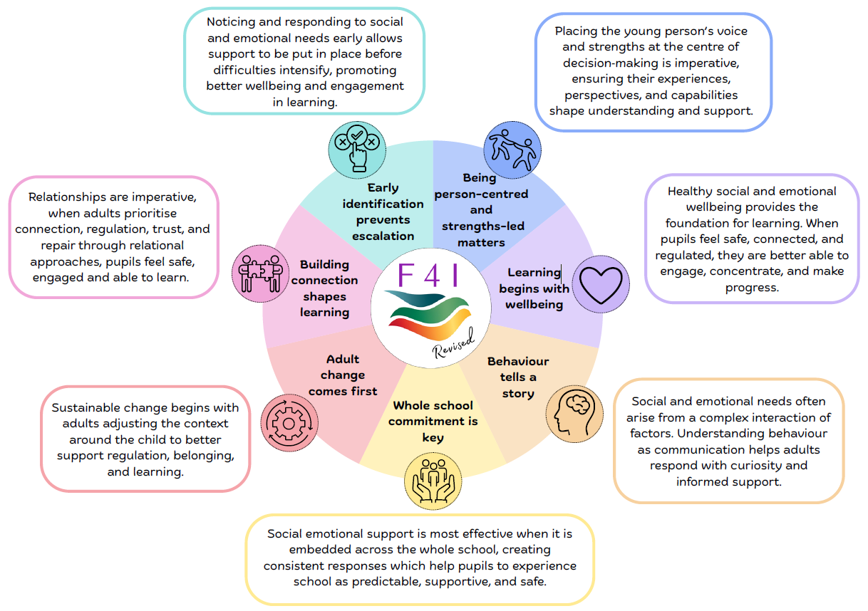

The Research Behind the Principles…

Healthy social and emotional wellbeing underpins learning, enabling pupils to feel safe, connected, and regulated so they can engage and make progress (Cipriano et al., 2023)

Whole-school, consistently implemented approaches produced statistically significant improvements in students’ social-emotional adjustment, behaviour, and internalising symptoms (Goldberg et al., 2019)

Universal, school-wide approaches provide the essential foundation for staff to effectively support pupils’ SEMH needs (Booth & Bond, 2025)

Without timely identification and support, SEMH needs can escalate into longer-term outcomes, making it essential for schools to adopt proactive, evidence-informed approach (Antalak et al., 2025)

Effective SEL relies on staff training and leadership support, with universal approaches forming the base and integrated targeted supports ensuring all students can reach positive outcomes (Greenberg, 2023)

Staff were better able to support SEMH pupils when they were approachable and demonstrated strong listening skills, which encouraged pupils to open up (Booth & Bond, 2025)

Listening to children with SEMH difficulties helps adults understand the whole child and respond appropriately, making their voices essential for shaping decisions and policies that genuinely meet their needs (Dolton et al., 2020)

Placing the pupil at the centre, giving them choice and ensuring key adults share and receive information was perceived to create a positive process that improved engagement and willingness to participate (Gray et al., 2022)

Person-centred planning strengthened relationships, improved understanding, supported collaborative information-sharing, and created a space for open dialogue that led to better engagement and more effective, co-produced solutions (Gray, 2021)

Children and young people’s behaviour is shaped by their experiences and often serves as a communication of underlying needs (Jones & Harding, 2023).

A trusting, supportive, and close relationship helps vulnerable children feel safe and able to thrive in school (Dolton et al., 2020)

A strong whole-school understanding of SEMH, recognising behaviour as communication and fostering a nurturing, shared-responsibility ethos was found to be key in effectively supporting pupils (Booth & Bond, 2025)

Prioritising connection, regulation, trust, and repair through strong relationships helps pupils feel safe, engaged, and ready to learn (Carroll & Hurry, 2019)

Strong, trusting relationships and a nurturing, inclusive classroom climate are key to fostering pupils’ wellbeing, belonging, and participation (Antalak et al., 2025)

Relationships were identified as a key factor enabling staff to effectively support young people with SEMH needs (Booth & Bond, 2025)


How to use this Handbook…
The Framework Decision Pathway on the next page is your starting point for moving through a graduated approach to identifying and supporting SEMH needs. It is designed as a clear, step-by-step flowchart that helps you pause, reflect, and make informed decisions at each stage of the process.

As you move through the Framework Decision Pathway:
- Follow the flowchart in order, beginning at the universal stage.
- Pause at each checkpoint and ask yourself the question in the box.
- Use your answer to determine the next appropriate action.

Support Available at Each Stage
At the Universal Phase, you may request an Assistant Psychologist to support you via your school Educational Psychologist (EP). At any stage of the pathway, if you feel that EP consultation or involvement is required, this is entirely appropriate. The pathway is not a gatekeeping tool; it is a structure to help you to make informed decisions and to feel competent to support SEMH needs in your setting.

Using the Further Information Sheets
As you progress through each phase of the Framework Decision Pathway, you can refer to the Further Information Sheets included in this handbook. These sheets:
- Explain the purpose of each phase
- How to move through the phase
- How to use the complementary resources

Resources Provided in This Handbook
To support you in working through the pathway, the handbook includes:

Universal Phase: The Classroom Development Tool | The Classroom Development Tool supports school staff, with Assistant Psychologist support, to support SEMH needs at a universal level. It employs an environmental checklist, reflection and a planning tool to guide action and development.
Targeted and Targeted Plus Phase: The SEMH Needs Insight Tool | The SEMH Needs Insight Tool is a resource that helps school staff to identify, understand and plan for underlying factors contributing to a pupil’s SEMH needs. It offers a holistic approach to assessing SEMH needs, so that staff can plan for effective action at the targeted and targeted plus phase.
The SEMH Needs Insight Toolbox | The SEMH Needs Insight Toolbox contains resources to support holistic assessment and planning for action at the targeted and targeted plus phases, it includes:  - Ideas for assessment  - A child’s voice resource  - An observation record to support assessment  - A meeting record to support assessment  - Ideas for intervention (primary settings)  - Ideas for intervention (secondary settings)

The Framework Decision Pathway
Individualised, intensive provision
Short-term, small-group provision
Universal Phase

Yes
CHECKPOINT
Does the review still indicate a SEMH need following implementation of actions and CPD at a targeted plus level?

Targeted Plus Phase
Using the insight gained from the SEMH Needs Insight Tool, use the action plan to plan for:
- Personalised intervention, delivered on a 1:1 basis
- Classroom adjustments
- Individualised strategies
- Bespoke resources
To complement this, attend a Collaborative Solutions Group to reflect on and problem-solve. Implement actions for a minimum of a term and then review progress.

Specialist Phase
Consult with your school’s Educational Psychologist about the steps you have taken with the framework so far. Agree actions with your Educational Psychologist in consultation for next steps. Implement intervention and provision for an agreed time period. Review progress with your Educational Psychologist after an agreed time period.

Work with your EP to develop next steps for intervention and/or additional resourcing within EP consultation.

Targeted Phase
Using the insight gained from the SEMH Needs Insight Tool, use the action plan to plan for:
- Short-term, evidence-informed small group interventions
- Classroom adjustments
- Targeted strategies
- Additional resources
Implement actions for a minimum of a term and then review progress.

Yes
No
CHECKPOINT
Are pupils accessing quality first teaching and are whole school relational SEMH policies being applied consistently?
CHECKPOINT
Is the pupil able to make progress with short-term and small-group support, or do they need more individualised, intensive support to access learning?
Explore individual needs through using the ‘SEMH Needs Insight Tool’ to better understand whether there are underlying difficulties and differences which may be contributing to SEMH needs and may require intervention. Consider…
- Biological factors
- Cognition development and learning factors
- Speech, language and communication factors
- Social factors
- Environmental factors
- Emotional factors
To complement this, upskill staff through accessing an EPS CPD course on Making Sense of SEMH: Assessing Underlying Factors and Planning for Intervention.

Yes
No
CHECKPOINT
Does the review still indicate a need for an individual pupil following implementation of actions at a universal level?

Implement actions for a minimum of six weeks and then review progress.

SEMH need still present
Explore what additional environmental adaptations can be implemented at the universal level to support. Complete ‘The Classroom Development Tool’, with an Assistant Psychologist to plan for action at a universal level.

Implement in-house professional development and support. Review progress half-termly.

First alert of a social, emotional and mental health need at either an individual or group level


Further Information Sheet
Universal Phase

The Classroom Development Tool

What is it?

The classroom development tool is completed during the universal phase of the framework. The tool is designed for school-based teams, supported by an Assistant Psychologist, to foster a positive classroom climate that promotes pupils’ social development, emotional regulation, positive behaviour and mental wellbeing. It includes three key components:
- A strengths-based environmental checklist which supports reflection on current classroom practice.
- A reflective phase which involves the identification of priority areas for development.
- A planning tool which supports targeted action for ongoing development.

How to use it…

Phase 1
Start with the Environmental Checklist, notice what’s working…
- Work collaboratively as a team, supported by an Assistant Psychologist, to make observations and reflections on current practice within the classroom.
- Identify strengths that can be built on.
- Look for areas that may benefit from development.

Phase 2
Have a reflective discussion to celebrate strengths and choose priorities for development…
- Review the completed checklist together, consider differing perspectives.
- Explore clear strengths and areas which may benefit from developing.
- Decide on three priority areas to take into the development plan.

Phase 3
Move onto the Development Plan…
- Translate insights from the reflective discussion into goals.
- Plan steps for development and note down how this will be achieved.

Review periodically…
- Revisit the tool to assess and refine approaches.
- Use the tool as part of ongoing professional development.


Universal Phase: The Classroom Development Tool

Phase 1: The Environmental Checklist
Notice what’s working and what needs to develop…
- The physical classroom environment
- Safety and security | Rate this area from 1 to 5 (1 = developing, 5 = strong and well established) |  |  |  |  |  | Notes
- Safety and security | 0  Not seen | 1 | 2 | 3 | 4 | 5 | Notes
Cleanliness & Organisation – The classroom is clean, organised and free from physical hazards such as clutter.
Furniture Arrangement – The furniture is arranged for easy movement and to prevent accidents or falls.
Materials Storage – Materials are stored safely and neatly, in appropriate containers with labels.
Accessible Resources – Frequently used resources (e.g. books) are easily accessible and organised for pupil independence.
Supervision – There is clear visibility of all areas of the classroom, ensuring effective teacher supervision.
- Comfort & Aesthetics | Rate this area from 1 to 5 (1 = developing, 5 = strong and well established) |  |  |  |  |  | Notes
- Comfort & Aesthetics | 0  Not seen | 1 | 2 | 3 | 4 | 5 | Notes
Lighting – There is adequate and balanced lighting, avoiding glare or dimness. There is access to as much natural light as possible.
Temperature & Ventilation – The classroom temperature is comfortable and there is adequate ventilation to ensure fresh air circulation.
Noise Level – Overall noise level is conducive to learning; and there are designated quiet zones as needed.
Visual Appeal – The classroom is visually appealing and stimulating, without being overly cluttered or distracting.
Pupil Work Display – Pupils work is displayed prominently and respectfully, celebrating their efforts and achievements.
Natural Elements – There are natural elements (e.g. plants, natural light) incorporated to create a calming and welcoming atmosphere.
- Learning Zones & Resources | Rate this area from 1 to 5 (1 = developing, 5 = strong and well established) |  |  |  |  |  | Notes
- Learning Zones & Resources | 0  Not seen | 1 | 2 | 3 | 4 | 5 | Notes
Defined Areas – There are clearly defined learning zones (e.g., reading nook, quiet work area, group collaboration space, creative corner).
Technology Integration – Technology is integrated thoughtfully and purposefully, with clear guidelines for use.
Sensory-Friendly Options – There are options for pupils with sensory needs (e.g., weighted blanks, ear defenders, sensory tools).
Comfort Items – There is a designated “calm-down” zone (or designated area) with comforting items and strategies for emotional regulation.
- Teacher practices and interactions
- Relationship Building & Connection | Rate this area from 1 to 5 (1 = developing, 5 = strong and well established) |  |  |  |  |  | Notes
- Relationship Building & Connection | 0  Not seen | 1 | 2 | 3 | 4 | 5 | Notes
Warm Welcome – The teacher greets pupils warmly and individually as they enter the classroom.
Positive Language – The teacher consistently uses positive, encouraging, and respectful language with pupils.
Role Modelling – Teacher demonstrates calm responses to challenging situations, acknowledges own emotions and uses ‘I’ statements.
Active Listening – The teacher actively listens to pupils, validating their feelings and perspectives.
Individualised Attention – The teacher makes an effort to connect with each pupil individually, showing genuine interest in their lives and well-being.
Building Rapport – The teacher engages in informal conversations with pupils, fostering a sense of rapport and trust.
Celebrating Success – The teacher acknowledges and celebrates pupils’ successes, both academic and social-emotional.
Humour & Light Heartedness – The teacher uses appropriate humour to create a positive and relaxed atmosphere.
- Social-Emotional Learning Integration | Rate this area from 1 to 5 (1 = developing, 5 = strong and well established) |  |  |  |  |  | Notes
- Social-Emotional Learning Integration | 0  Not seen | 1 | 2 | 3 | 4 | 5 | Notes
Self-Awareness & Self-Management Skills – The teacher explicitly teaches social-emotional skills, e.g., identifying emotions, coping strategies, self-regulation.
Emotional Vocabulary – The teacher encourages and supports the use of emotional vocabulary among pupils.
Emotion Regulation Strategies – The teacher models and teaches effective strategies for emotional regulation.
Empathy & Perspective-Taking – The teacher facilitates discussions and activities that promote empathy and understanding of diverse perspectives.
Conflict Resolution – The teacher guides pupils through conflict resolution processes, teaching them to problem-solve peacefully.
Problem-Solving Skills – The teacher encourages and supports pupils in developing independent problem-solving skills for social challenges.
Growth Mindset – The teacher fosters a growth mindset, encouraging pupils to see challenges as opportunities for learning and growth.
- Behaviour Management & Regulation | Rate this area from 1 to 5 (1 = developing, 5 = strong and well established) |  |  |  |  |  | Notes
- Behaviour Management & Regulation | 0  Not seen | 1 | 2 | 3 | 4 | 5 | Notes
Clear Expectations – The teacher clearly communicates and consistently reinforces classroom expectations and routines.
Positive Reinforcement – The teacher primarily uses positive reinforcement to encourage desired behaviours.
Proactive Strategies – The teacher uses proactive strategies to prevent challenging behaviours (e.g., engaging lessons, clear transitions, adapted instruction).
Consistent Consequences – Consequences for misbehaviour are delivered consistently, fairly, and are educative (aimed to teach not to punish).
Restorative Practices – The teacher uses restorative practices to address harm and promote repair when conflicts arise.
De-Escalation Techniques – The teacher is skilled in de-escalation techniques to manage challenging behaviours calmly and effectively.
Opportunities for Choice – The teacher provides appropriate opportunities for pupil choice to promote autonomy and self-regulation.
Minimising Power Struggles – The teacher avoids engaging in power struggles with pupils, seeking collaborative solutions instead.
- Promoting Mental Health & Well-Being | Rate this area from 1 to 5 (1 = developing, 5 = strong and well established) |  |  |  |  |  | Notes
- Promoting Mental Health & Well-Being | 0  Not seen | 1 | 2 | 3 | 4 | 5 | Notes
Stress Reduction – The teacher incorporates strategies to reduce stress and anxiety in the classroom (e.g. mindfulness, guided meditation, belly breathing).
Sense of Belonging – The teacher actively fosters a sense of belonging and community among all pupils.
Safe Space for Expression – The classroom is a safe space where pupils feel comfortable expressing their thoughts and feelings without fear of judgement.
Open Communication – The teacher maintains open communication with pupils (and their families) about well-being concerns.
Promoting Self-Care – The teacher implicitly or explicitly promotes self-care strategies with pupils (e.g. adequate sleep, healthy eating).
Resilience Building – The teacher helps pupils develop resilience by teaching them how to cope with setbacks and challenges.
Valuing Diversity – The teacher actively promotes inclusivity and respect for diversity, addresses bullying promptly and ensures equitable participation.
- Student engagement and participation
- Active engagement and participation | Rate this area from 1 to 5 (1 = developing, 5 = strong and well established) |  |  |  |  |  | Notes
- Active engagement and participation | 0  Not seen | 1 | 2 | 3 | 4 | 5 | Notes
Opportunities for Voice – There are frequent opportunities for pupils to share their ideas, opinions and feelings.
Collaborative Learning – The teacher facilitates collaborative learning activities that encourage teamwork and peer interaction.
Pupil Choice & Autonomy – Pupils have opportunities for choice in their learning activities and assignments, fostering engagement and ownership.
Differentiated Instruction – The teacher adapts methods of instruction as well as curriculum content to meet the diverse learning needs and interests of all pupils.
Challenging & Engaging Tasks – The learning tasks are appropriately challenging and engaging, promoting curiosity and intrinsic motivation.
- Classroom community and collaboration | Rate this area from 1 to 5 (1 = developing, 5 = strong and well established) |  |  |  |  |  | Notes
- Classroom community and collaboration | 0  Not seen | 1 | 2 | 3 | 4 | 5 | Notes
Collaborative Problem-Solving – Pupils engage in collaborative problem-solving, learning from and with their peers.
Respectful Interactions – The teacher encourages pupils to demonstrate respectful interactions and communication with each other.
Group Cohesion – The teacher implements activities that build group cohesion and a sense of shared purpose.
Valuing Contributions – All pupils’ contributions to group work and discussions are valued and acknowledged.
Peer Mentoring/Support – There are opportunities for pupils to support and mentor their peers.

Phase 2: Post Checklist Reflection
Celebrate strengths and choose next steps…
Development Focus 1

Development Focus 2

Development Focus 3

Phase 3: The Development Plan
Develop a plan for achieving your next steps…
Development Focus 1

Build on strengths… |  |  | Notice impact…
What are we already doing that helps? | What next step will we try? | Who or what will support this to happen? | What positive difference will we notice? What will it look like? | Review

Development Focus 2

Build on strengths… |  |  | Notice impact…
What are we already doing that helps? | What next step will we try? | Who or what will support this to happen? | What positive difference will we notice? What will it look like? | Review

Development Focus 3

Build on strengths… |  |  | Notice impact…
What are we already doing that helps? | What next step will we try? | Who or what will support this to happen? | What positive difference will we notice? What will it look like? | Review

Further Information Sheet
Targeted and Targeted Plus Phases
The SEMH Needs Insight Tool

What is it?

The SEMH Insight Tool is completed at the targeted phase of the framework. It is a structured resource designed to support teams within school to identify, understand and plan for underlying factors that may be contributing to SEMH needs for individual pupils.
Looking beyond the behaviour
SEMH needs and behaviours are often the visible signs of experiences, needs, or challenges that lie beneath the surface. What we see in school, such as anger, withdrawal, defiance, anxiety, or difficulties managing emotions, may be a child’s way of communicating that something is not going well for them. A wide range of interconnected factors can influence how a child feels, behaves, and engages with learning, including their relationships, life experiences, physical and emotional wellbeing, neurodevelopmental differences, family circumstances, and the environment around them. By looking beyond the behaviour and approaching children with curiosity rather than judgement, practitioners can develop a deeper understanding of what may be driving their SEMH needs and identify the most appropriate ways to support them. The SEMH Insight Tool offers a holistic approach to assessment, to support staff to look beyond presenting behaviours and consider factors that may be underlying these needs.
How to use it…
Start with the holistic assessment…
- Work collaboratively as a team to ask why this SEMH need may be happening.
- Using suggested tools from the SEMH Needs Insight Toolbox (Assessment), carry out assessment and use data to consider factors that may be underlying SEMH needs. Consider:
- Biological factors
- Cognition development and learning factors
- Speech, language and communication factors
- Social factors
- Environmental factors
- Emotional factors
- Complete the ‘Understanding My World’ tool with the child to elicit their voice/perspective which can be used to inform planning.

Plan for intervention…
Consider whether the pupil may be able to make progress with short term or small group support, or whether they need individualised, intensive support. If their needs can be met with short-term or small group support, plan for action at the targeted phase. If needs require more individualised, intensive support, plan for action at the targeted plus phase.

Targeted Phase | Targeted Plus Phase
Plan for action by considering…  - Short-term, evidence-informed small group interventions  - Classroom adjustments  - Targeted strategies  - Additional resources | Plan for action by considering…  - Personalised intervention, delivered on a 1:1 basis  - Classroom adjustments  - Individualised strategies  - Bespoke resources

The SEMH Needs Insight Tool
Framework for Intervention Revised

The Holistic Assessment
Speech and Language Factors

Biological Factors

Cognition Development and Learning Factors

Emotional Factors

Environmental Factors

Social Factors

SEMH Needs

Consider challenges and strengths/protective factors

The Holistic Assessment: Understanding the different factors
Speech and Language Factors

Difficulties understanding language, expressing thoughts and feelings, processing information or using language in social situations can impact emotional wellbeing, behaviour and relationships. Communication differences can sometimes be mistaken for disengagement, defiance or lack of motivation.

Biological Factors
Physical and developmental factors may influence how a child or young person experiences and responds to the world. These may include neurodevelopmental differences, sleep, nutrition, medical conditions, sensory needs, hormonal changes or aspects of a child's developmental history.

Cognition Development and Learning Factors
Children or young people may experience frustration, anxiety or reduced self-confidence when learning is difficult. Factors such as cognitive processing, executive functioning, attention, specific learning difficulties, motivation and academic attainment can all influence a child's emotional wellbeing and behaviour

Emotional Factors
Children's ability to identify, understand and regulate emotions develops over time and is influenced by their experiences and relationships. Emotional literacy, self-esteem, resilience, feelings of safety, anxiety, emotional regulation and emotional triggers are all important areas to explore.

Environmental Factors
Children are influenced by the environments in which they live and learn. Classroom experiences, relationships with adults and peers, transitions, school culture, home circumstances and wider community factors can all contribute to how children feel and behave.

Social Factors

Social experiences play a significant role in emotional wellbeing. Friendships, social skills, sense of belonging, conflict resolution, social communication and access to supportive relationships can all affect a child's ability to thrive in school.

The Holistic Assessment: A summary of factors to consider
Speech and Language Factors
Expressive language skills
Receptive language skills
Vocabulary development
Use of language in social contexts
Speech clarity and articulation
Language processing speed
Narrative skills
Non-verbal communication
Social interaction

Biological Factors
Neurodevelopmental differences
Sleep patterns
Nutrition and diet
Medical conditions
Medication
Sensory and physical differences
Hormonal changes
Early development
Temperature regulation
Genetic predisposition

Cognition and Learning Factors
Cognitive ability and processing skills
Executive functioning (planning, organisation, flexible thinking)
Learning style and preferences
Academic attainment and progress
Specific learning difficulties
Attention and concentration
Problem-solving and reasoning skills
Motivation and engagement
Impact of cognitive load
Pace of the curriculum
Interest and motivation

v
Emotional Factors
Emotional awareness
Emotional regulation
Self-esteem and self-concept
Resilience and coping skills
Attachments and feelings of safety
Sense of belonging
Mood and affect
Anxiety
Motivation and emotional drive
Emotional triggers

Environmental Factors
Classroom climate
Physical environment
School culture and ethos
Peer relationships
Teacher-pupil relationships
Access to support
Transitions and routines
Home environment
Community and cultural context
Access to resources

Social Factors
Peer relationships
Social skills development
Group participation
Conflict resolution skills
Empathy and perspective taking
Influence of peer pressure
Social communication
Sense of belonging
Community influence
Support networks

SEMH Needs

Understanding My World…


Important people in my life…

Things that are going well for me…



Things that I am working on…

Things that make my life harder…

Things I wish adults knew…



Planning for Targeted Intervention
Area and focus for intervention | Targeted action (OAG ALL SECTIONS):  - Short-term, evidence-informed small group interventions  - Classroom adjustments  - Targeted strategies  - Additional resources | Time frame for implementation | Review

Planning for Targeted Plus Intervention
Area and focus for intervention | Targeted action:  - Personalised intervention, delivered on a 1:1 basis  - Classroom adjustments  - Individualised strategies  - Bespoke resources | Time frame for implementation | Review
The SEMH Needs Insight Toolbox
Framework for Intervention Revised

Ideas for Assessment
Speech and Language Factors
Observation of interactions
Record keeping e.g. of vocabulary development
Communication Trust Progression Tools
WellComm Toolkit
Liaison with SALT
Birmingham SEN Toolkits
EYFS Profile (early years)
Language Link (primary)
Meetings with parents/carers

Biological Factors
Meetings with parents/carers
School health records and individual healthcare plans
Liaison with health professionals
Observation
Record keeping e.g. signs of tiredness, energy levels
Check-ins and supportive conversations with pupils

Cognition and Learning Factors
Teacher consultation
Observation
LLSS assessment where appropriate
Executive functioning checklists
Analysis of attainment data
Birmingham SEN toolkits
Meetings with parents/carers

v
Emotional Factors
Observation
Emotion charts
Check-ins and supportive conversations with pupils
Meetings with parents/carers
Monitor patterns in emotion/mood/affect
Emotion screening tools
ABC Charts
Functional Behaviour Analysis

Environmental Factors
Observation
Meetings with parents/carers
Pupil voice work
A review of behaviour policy
School climate surveys

Social Factors
Observation in class and during unstructured times
Sociograms to map friendships and social networks
Use learning tasks which involve empathy and perspective taking
Track attendance and engagement as indicators of sense of belonging
Meetings with parents/carers
Strengths and Difficulties Questionnaire
SCERTS framework (social communication)
Involvement from CAT where appropriate

The SEMH Needs Insight Toolbox
Observation Record
Description of observed behaviour

Child or young person’s name:
Date and time:
Context (location, lesson context):
Observer name:
Biological factors to consider

Speech and language factors to consider

Social factors to consider

Cognition and learning factors to consider

Environmental factors to consider

Emotional factors to consider

The SEMH Needs Insight Toolbox
Meeting Record
Actions and Responsibilities
Child or young person’s name:
Date and time:
Present:
Biological factors

Speech and language factors

Social factors

Cognition and learning factors

Environmental factors

Emotional factors

Possible contributing factors…
What is going well?
Current concerns and needs

Ideas for intervention (Primary schools)
The following interventions provide illustrative examples of support that may be appropriate; this is not an exhaustive list.
Speech and Language Factors
- WellComm Toolkit- screening and intervention for early language development
- Colourful Semantics- supports sentence structure and grammar using colour coding
- Talk Boost- small group intervention to boost oral language skills
- Nuffield Early Language Intervention (NELI)- targeted support for vocabulary and comprehension
- ICAN Early Talk- early years communication development
- Word Aware-structured vocabulary teaching programme
- Speech Link & Language Link- intervention for speech and language difficulties
- Time to Talk- social communication skills in younger children
- Socially Speaking- pragmatic language and social interaction
- Intensive interaction- for pupils with profound communication difficulties

Biological Factors
Advice should be sought from health services for interventions

Cognition and Learning Factors
- Read Write Inc.-phonics based programme for early reading
- Precision Teaching- targeted fluency practice for decoding sight words
- Rapid reading- structured intervention for struggling readers
- Talk for Writing- develops writing through oral storytelling and modelled text
- Write from the Start- handwriting and fine motor skills programme
- Colourful Semantics- supports sentence structure and grammar
- Visual timetables and chunking strategies- reduces cognitive load
- Structured peer tutoring- reading practice through pairing older and younger children
- Toe by Toe- structured phonics for severe reading difficulties
- Attention Autism- structured sessions to build attention and engagement
- Movement breaks and sensory circuits- improves focus and regulation
- Numicon- concrete resources for mathematical reasoning
- Thinking Skills Programme- puzzles and logic tasks embedded in the curriculum
- Growth Mindset Programmes
- Choice boards- increases autonomy and engagement

v
Emotional Factors
- ELSA- teaches emotional literacy and regulation through intervention
- Emotion Coaching- evidence based approach for building trust and supporting regulation
- Attachment Aware Practice (TIAAS)- strategies informed by attachment theory to strengthen relationships
- Mindfulness- short daily practice to improve self-regulation
- My Magnificent Mind- a psychoeducation programme for KS2
- Bounce Back Programme- resilience-building curriculum for primary
- Key adult support- consistent adult relationships for vulnerable pupils
- Daily check-in systems- emotional check-ins with a trusted adult
- FRIENDS for Life-CBT-based anxiety programme

Environmental Factors
- Nurture Groups- small group provision to create a safe, structured environment for pupils
- Sensory-friendly classroom adaptations and flexible seating programmes

Social Factors
- Circle of friends- builds peer support networks for pupils experiencing isolation
- Peer mentoring programmes- structured mentoring between older and young pupils
- Buddy systems- pairing pupils to promote inclusion and friendship
- Time to talk- develops conversational and interaction skills
- Socially speaking- structured activities to improve pragmatic language and social competence
- Circle time- regular sessions to build group cohesion and shared problem solving
- Restorative practice- teaches pupils to repair harm and resolve disputes constructively
- PATHS (Promoting Alternative Thinking Strategies)- SEL programme which includes empathy building activities
- Social use of language (SULP)- pragmatic language and social interaction skills
- SCERTS Framework- supports social communication and emotional regulation
- Social Stories- helps teach pupils about social behaviours
- Comic Strip Conversations- helps pupils to use perspective-taking

promoting

Ideas for intervention (Secondary schools)
The following interventions provide illustrative examples of support that may be appropriate; this is not an exhaustive list.
Speech and Language Factors
- Talk Boost- small group intervention to boost oral language skills
- Word Aware- vocabulary enrichment for older learners
- Language for Thinking- reasoning and inference skills
- Social use of Language Programme (SULP)- pragmatic and social communication skills
- Language link- assessment and intervention for comprehension and expressive language
- Vocabulary enrichment programme- structured approach for academic language development
- Intensive interaction- for pupils with profound communication difficulties

Biological Factors
Advice should be sought from health services for interventions

Cognition and Learning Factors
- Lexia PowerUp Literacy- adaptive programme for older struggling readers
- Inference Training- improves comprehension
- Reciprocal Reading- collaborative approach to comprehension strategies
- Writing Frames and Scaffolds- support structure for essays and extended writing
- Chunking and Graphic Organisers- reduces cognitive load for complex tasks
- Study Skills Programmes- teaches organisation, planning and time management
- Metacognitive Strategies- explicit teaching of ‘thinking about thinking’
- Touch Type Read and Spell- supports spelling and keyboard skills
- Mindfulness-based interventions- short daily practice to improve focus
- Pomodoro Technique Adaptations- structured work-break cycles
- Personalised Learning plans- links tasks to interests and strengths
- Peer Tutoring Programmes- boosts confidence and engagement through collaboration

v
Emotional Factors
- CBT workbooks- helps pupils identify thoughts, feelings and behaviours
- Mindfulness-based interventions- short daily practice to improve focus
- ELSA- teaches emotional literacy and regulation through intervention
- Emotion Coaching- evidence based approach for building trust and supporting regulation
- Attachment Aware Practice (TIAAS)- strategies informed by attachment theory to strengthen relationships
- Key adult support- consistent adult relationships for vulnerable pupils
- Daily check-in systems- emotional check-ins with a trusted adult
- Mentoring programmes- peer or adult mentor to build confidence
- FRIENDS for Life- CBT based resilience and anxiety programme
- Bounce Back- resilience curriculum

Environmental Factors
- Nurture Groups- small group provision to create a safe, structured environment for pupils
- Sensory-friendly classroom adaptations and flexible seating programmes

Social Factors
- Circle of friends- builds peer support networks for pupils experiencing isolation
- Peer mentoring programmes- structured mentoring between older and young pupils
- Buddy systems- pairing pupils to promote inclusion and friendship
- Time to talk- develops conversational and interaction skills
- Socially speaking- structured activities to improve pragmatic language and social competence
- Circle time- regular sessions to build group cohesion and shared problem solving
- Restorative practice- teaches pupils to repair harm and resolve disputes constructively
- Second Step- teaches emotional literacy and perspective taking
- PATHS (Promoting Alternative Thinking Strategies)- SEL programme which includes empathy building activities
- Social use of language (SULP)- pragmatic language and social interaction skills
- SCERTS Framework- supports social communication and emotional regulation
- Social Stories- helps teach pupils about social behaviours
- Comic Strip Conversations- helps pupils to use perspective-taking

promoting
Further Information Sheet
Targeted Plus Phase

Collaborative Solutions Groups

A Collaborative Solutions Group is a structured forum where professionals from different schools come together to address complex challenges. At the targeted plus phase, schools are encouraged to attend a collaborative solutions group and bring their case for further formulation and problem-solving with staff from other schools who may have experienced something similar. The group uses a psychological consultation model to explore issues, share perspectives, and co-create practical solutions.

Key features of a Collaborative Solutions Group:

- Problem-Solving Approach: Participants bring real-world challenges for the group to consider and come up with solutions for collaboratively.
- Facilitated by an Educational Psychologist (EP): The EP guides the process using evidence-based consultation frameworks to ensure discussions are purposeful and solution-focused.
- Multi-Setting Collaboration: The group values diverse viewpoints and shared learning across schools.
- Solution-focused: Each session aims to generate actionable strategies that can be implemented in practice.

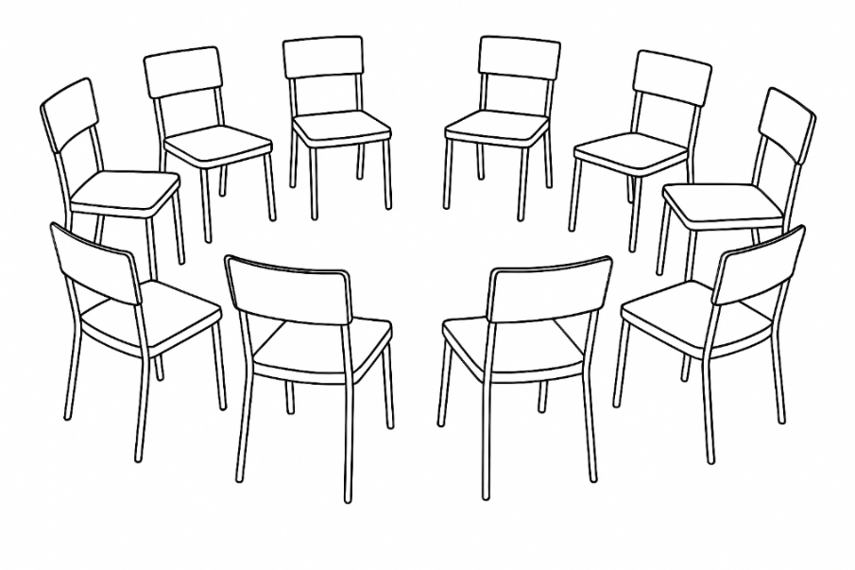

If you are interested in attending a Collaborative Solutions group, please speak to your visiting Educational Psychologist.

Further Information Sheet
Specialist Phase

Consulting with your school’s EP

Following the targeted phases, if the SEMH need is persisting and there has been limited progress in response to targeted intervention, it may be beneficial to consult with your school’s Educational Psychologist (if you haven’t already done so). The evidence gathered from the universal and targeted phases can be used to support this consultation and demonstrate there has been a graduated approach.

The EP can then assist with:
- Further assessment of the pupil’s needs
- Consultation
- Further training and/or supervision of staff
- Planning of additional interventions or adaptations to ensure that interventions have greater impact
- Further decisions regarding next steps



