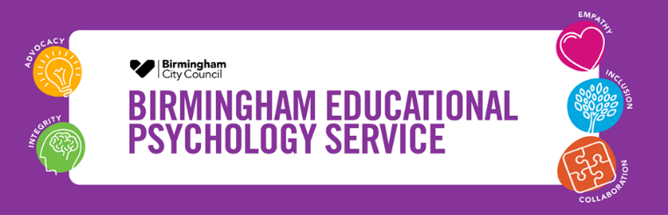
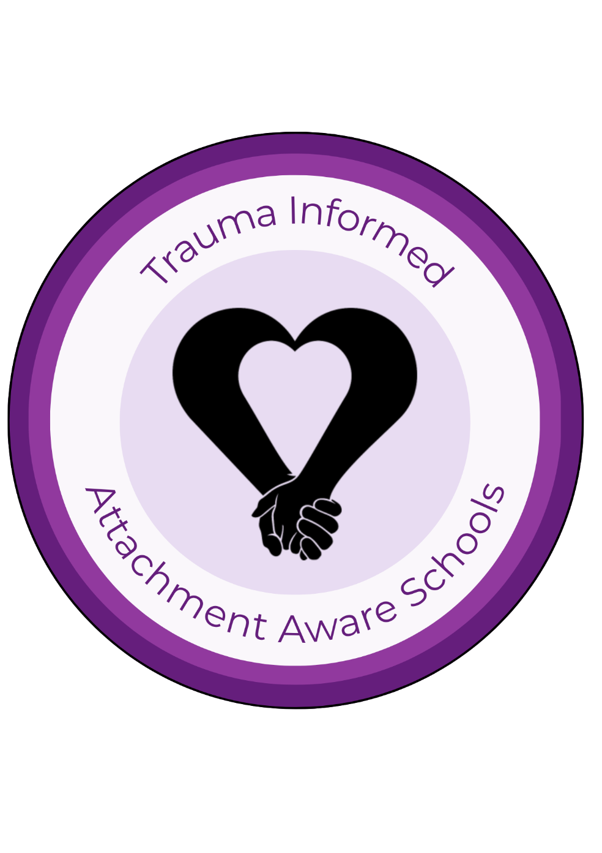

In partnership with:

The Trauma Informed Attachment Aware Schools Programme

TIAAS

A Practical Guide

Welcome to the Trauma Informed Attachment Aware Schools (TIAAS) Programme!

What is TIAAS?
TIAAS is a whole school development programme that supports schools to become relational in their practice. It is part-funded by the Virtual School in Birmingham and delivered by the Birmingham Educational Psychology Service. The Virtual School support and advocate for schools to consider committing to this programme, as current research and policy indicate that whole school trauma-informed and attachment aware practice supports vulnerable pupils to have positive outcomes. Birmingham Educational Psychology Service advocate for this programme because in addition to its benefits for vulnerable pupils, relational practice at a whole school level can support the social and emotional development of all pupils.

Understanding Relational Practice
Relational practice is an “umbrella term”. It encompasses those approaches which prioritise the development and maintenance of positive relationships, to provide connection and belonging. You may have heard of restorative practice and may be using restorative approaches currently in your setting; this approach along with trauma-informed and attachment aware approaches are all considered as relational.
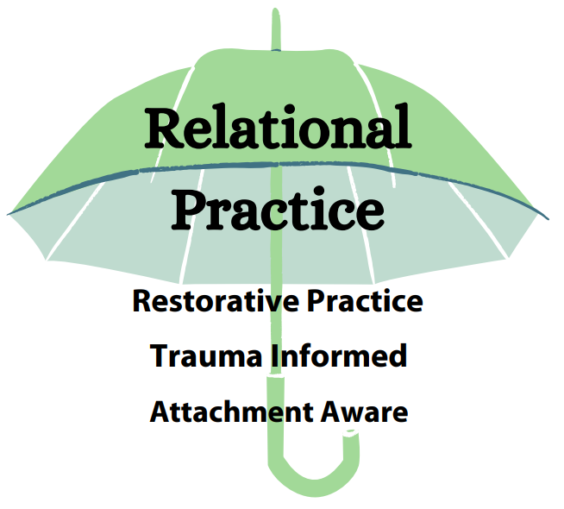

Restorative Practice in an educational context can be described as restoring good relationships when there has been conflict or harm and developing school ethos, policies and procedures to reduce the possibility of such conflict and harm arising.

Hopkins (2016) describes the values, beliefs and core elements which make up restorative practice. This includes the importance of:
- strong, respectful relationships that keep communities safe;
- repairing relationships when things go wrong;
- commitment to putting things right and moving on when harm is caused;
- face to face encounters between the harmed and wrongdoer;
- opportunity for all involved to share their story and to have their voice heard;
- those involved having a say about what needs to happen to move forward; and
- dialogue as a means to finding these ways forward that are mutually agreed.

Attachment Awareness is an understanding of the impact of attachment relationships on a child’s development and how to recognise and support unmet attachment needs.

Attachment is an enduring emotional tie to a special person, characterised by a tendency to seek and maintain closeness, especially during times of stress.
Trauma Informed Practice is a way of working which demonstrates an understanding of the impact of trauma on individuals and communities, and shapes their practice to promote resilience and recovery.

Trauma can be defined as “an event, a series of events or set of circumstances that is experienced as physically or emotionally harmful or life-threatening, that overwhelms a person’s ability to cope and has lasting adverse effects on their mental, physical, social and emotional or spiritual well-being.” Treisman (2020)

Introducing the TIAAS Principles

The following principles are the golden thread that runs through all that is TIAAS. All TIAAS schools, by working to become relational in their approach, become aligned with the following:


The TIAAS Programme: An Overview

The following illustration provides an overview of the TIAAS programme. Schools begin the programme when they are ready for affecting change and so, you will see your first step is determining your school’s readiness to join the TIAAS programme. The steps which follow involve a cycle of planning, learning, implementing and reviewing progress over time. Further information about each step is provided in the subsequent pages.

Step 1: Determining your Readiness for TIAAS

The following flowchart is a useful starting point to determine how ready your school is for TIAAS. It provides helpful advice should you feel you are not at the point where you want to proceed.
Are all senior leaders committed to supporting effective implementation of the TIAAS programme?
Are all senior leaders prepared to be responsible for the implementation of the TIAAS programme?
Will the TIAAS programme, a relational approach to supporting children and young people, be made a priority in the school’s development plan?
Yes
Yes
Consider having further conversations as a SLT before revisiting the TIAAS programme.
No
No
No

Yes

Is there capacity to release two TIAAS lead practitioners within school to attend monthly TIAAS events, and can cover be made available if required?
Is there time within your inset programme to fulfil the training commitments (three half day slots of whole school training across the year)?

Are there adequate resources to support the implementation of the programme, including funding and a commitment across the year for ensuring implementation?

Yes
Yes
Revisit the TIAAS programme in the future when resources become available.
No
No
No

Yes

Great! You are logistically prepared for committing to the TIAAS programme. Move onto the next set of questions to consider if the programme is appropriate for your school staff.
Do school staff feel there is a need for change, to better understand and respond to the social and emotional development of their learners?
Do staff have the self-efficacy to believe that they are able to make changes to their approach as a result of engaging with TIAAS?

Yes

Yes
No
No
Consider having a TIAAS briefing to explore this with staff to assess attitudes, self-efficacy and capacity for change. Re-visit the programme in the future.

No
Have staff been briefed on the TIAAS programme? Do they understand the objectives? Do they understand why you are considering this programme at this time?

Consider having further reflective conversations with staff about barriers to self-efficacy and capacity for change, and ways to address these barriers. Re-visit TIAAS.
Great! Your staff sound ready to engage with the programme and to make positive change to their practice. Move onto the next page to see if your culture and ethos aligns or has the potential to align with the key principles of TIAAS.
Yes

Step 1: Determining your Readiness for TIAAS

The following steps in the flowchart can be used to assess whether your school’s ethos and culture aligns with the principles of TIAAS.
Do staff see or want to see behaviour as communication? Are staff curious about the experiences, emotions and unmet needs which may be driving behaviour?
Are staff or do staff want to be curious about the experiences of families, including experiences of adversity and trauma and what that means for them now?
Do staff strive or want to strive to form positive relationships with learners, and do they recognise the importance of relationships for effective learning?

Yes
Yes

Yes
No
No
No

TIAAS may not align with your school culture and ethos. Consider having reflective conversations with your EP.

Do staff accept or want to accept all of learners’ emotions and offer empathy before helping them to learn from problematic behaviour?
Do staff help or want to help learners to regulate before using reasoning, and before expecting them to repair ruptures to relationships and to learn from their behaviour?
Do staff recognise or want to recognise that a sense of safety is the foundation of all learning and exploration, and will staff strive to make school a safe space?
Yes
Yes
TIAAS may not align with your school culture and ethos. Consider having reflective conversations with your EP.

No
No
No

Yes

Great! You sound like you are aligned with the key principles of TIAAS. You are ready and committed to change and so are now ready to begin the TIAAS programme!

The Engagement Events

If you have worked through the flowchart and feel ready to proceed with TIAAS, the next step will be to attend the TIAAS Engagement Events. You will firstly need to identify two TIAAS leads within school; it is important that both people have roles within school where they can affect change. We would recommend that both leads are from SLT or if this isn’t possible that there is one member of SLT within the TIAAS team. Once identified, the leads will be able to book onto our next Engagement Event. The events are intended to support further consideration of readiness for change and planning for next steps with your TIAAS journey.

Step 2: Beginning your school’s TIAAS journey

The Attachment Aware Schools Audit

If it’s decided after the Engagement Events, that your setting is reading to embark with the next steps of the TIAAS programme, you will be asked to complete the Attachment Aware Schools Audit. The audit is a mechanism to explore your current practice, knowledge and competence in areas relating to trauma-informed attachment aware practice. It helps to identify areas of strength and areas for development, which can be incorporated into a development plan and used to individualise the training workshops. The audit is typically completed by SLT, led by the TIAAS leads and following its completion, you will have the opportunity to meet with the school’s visiting EP who will support you to put together a development plan. The audit can then be used as a monitoring tool to assess your progress and identify ongoing areas for development.

The illustration below provides an overview of the areas the audit asks you to assess:

Step 3: The TIAAS Training Workshops

The TIAAS training content is split into three half day, whole school workshops. The purpose of drip-feeding the theory in this way is to support with more successful implementation. It allows for regular review and rehearsal of the skills obtained within the workshops and provides opportunities for problem solving and reflection that one-off training does not provide. The training content for each workshop is directly related to the golden thread of TIAAS (the TIAAS principles) and is illustrated below. Although there is pre-determined content within the training, courses can be adapted by your Educational Psychologist, to reflect that which may have come up during your pre-consultation and auditing, and to suit your own school community or staff, pupils and families.

Steps 4 and 5: Implementation Planning and Support

After each workshop there will be a chance for staff to have a go at implementing what they have learned within the session and then to reflect upon this practice during the subsequent training sessions.
Following the final workshop, there will be a period of implementation (a month minimum) and then a post-training consultation with an Educational Psychologist. It is also at this point that the Attachment Aware Schools Audit is reviewed; to identify areas of progress and further areas for development.
To further support implementation, the TIAAS leads will be invited to different sessions led by the Educational Psychology Service which are illustrated below:




In addition to the events offered, there are other ways in which the Educational Psychology Service can support with implementation. Examples include:
- Bespoke twilight or inset training on areas of relational or related practice.
- Support for staff well-being including staff supervision.
- Trauma informed consultations or the development of Relational Support Plans for individual children and young people.
- Further support for SLT around affecting organisational change.
- Learning walks and feedback to assess ethos, culture and environmental factors.

Step 6: Certification




With the TIAAS programme there is the opportunity to move towards gaining certification to recognise your progress in becoming a relational setting. After a year following your training, there will be an opportunity to review your progress with your visiting Educational Psychologist. It is here that the EP will support you to consider your school’s strengths and the progress made. Following this, if your school has met the criteria for a bronze award, you will receive certification to celebrate and recognise your achievements, and will be able to use the relevant TIAAS logo on your school’s publicity/letters etc. You will also be supported at this time, to consider possible next steps to build on the progress you have made, so that you can work towards achieving a silver or gold award in the future.

Your school can apply for a silver or gold award at any time in your TIAAS journey, if you feel you are meeting the criteria as outlined in the certification booklet. This involves a period of data collection, where information is gathered and assessed against the certification criteria. Following a period of assessment, a decision is made as to whether your school has met the criteria for the award, and if so, the school receives the award at the annual Virtual School Conference. The following diagrams illustrate the areas explored during the certification process and the evidence required for silver and gold certification.

Areas explored: Evidence required:

Step 7: Evaluating the TIAAS Programme

As the TIAAS programme is focussed on changing practice within schools to develop universal approaches to promote the development and wellbeing of all children and staff, schools are required to evaluate the impact of their school development as part of the programme.
This evaluation takes place in several forms. There are two evaluation components which are mandatory within the first 12 months of the programme, however many schools choose to gather additional data as they progress through their journey.
Mandatory evaluation
- Attitudes Related to Trauma-Informed Care Scale (ARTIC) completed by all staff who attend the workshops prior to the training programme and 12 months after the final workshop.
- All schools monitor their development using the Certification Toolkit.
Examples of additional, optional, evaluation
- Parent and staff questionnaires.
- Pupil voice via individual or focus group measures.
- Learning walks.
More about the ARTIC scale
The TIAAS programme aims to support schools to develop ways of working and a culture and ethos which prioritises relational practice. In order to do this, perspectives on why students behave the way they do and the role that school-based staff can have in supporting students and each other is covered in the training.
The ARTIC scale is used because it measures staff’s attitudes and beliefs and we want to know if the programme has an impact on how staff view their role at school. The scale includes questions about staff’s views on the following:

Staff do not need to put their name on the questionnaire as it is completely confidential. The school’s data will be viewed as a whole and compared with the data collected 12 months after completion of the training.
Sample of ARTIC questionnaire
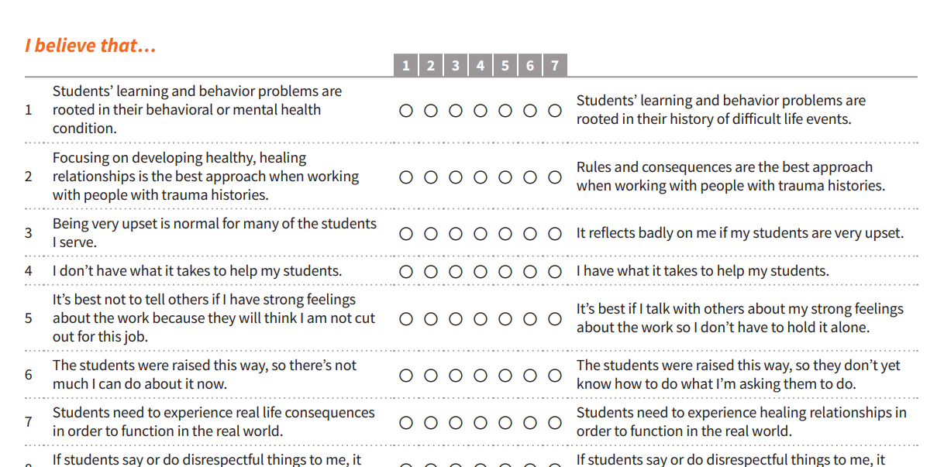

As the
Step 8: TIAAS Local Lead Practitioners

Local Lead Practitioners (LLPs) are TIAAS Leads from schools and nurseries who have achieved certification to recognise their practice in implementing trauma informed attachment aware approaches, which has been well embedded across their school setting. These LLPs are seconded with a role to provide school-to-school support across the City to share good practice through:
- hosting open events at their school;
- inspiring, building connections and community between schools who want to develop TIAAS practice;
- producing and disseminating resources based on good practice in Birmingham schools;
- supporting schools with implementation of the TIAAS principles, developing action plans and identifying resources to support them; and
- building relationships and monitoring the development of TIAAS practice within schools.
When schools have completed their review 12 months after their TIAAS training, then they will be referred on for support from a LLP with implementation and embedding of TIAAS across their whole school setting.

